CY Advanced Studies
Research in group programme
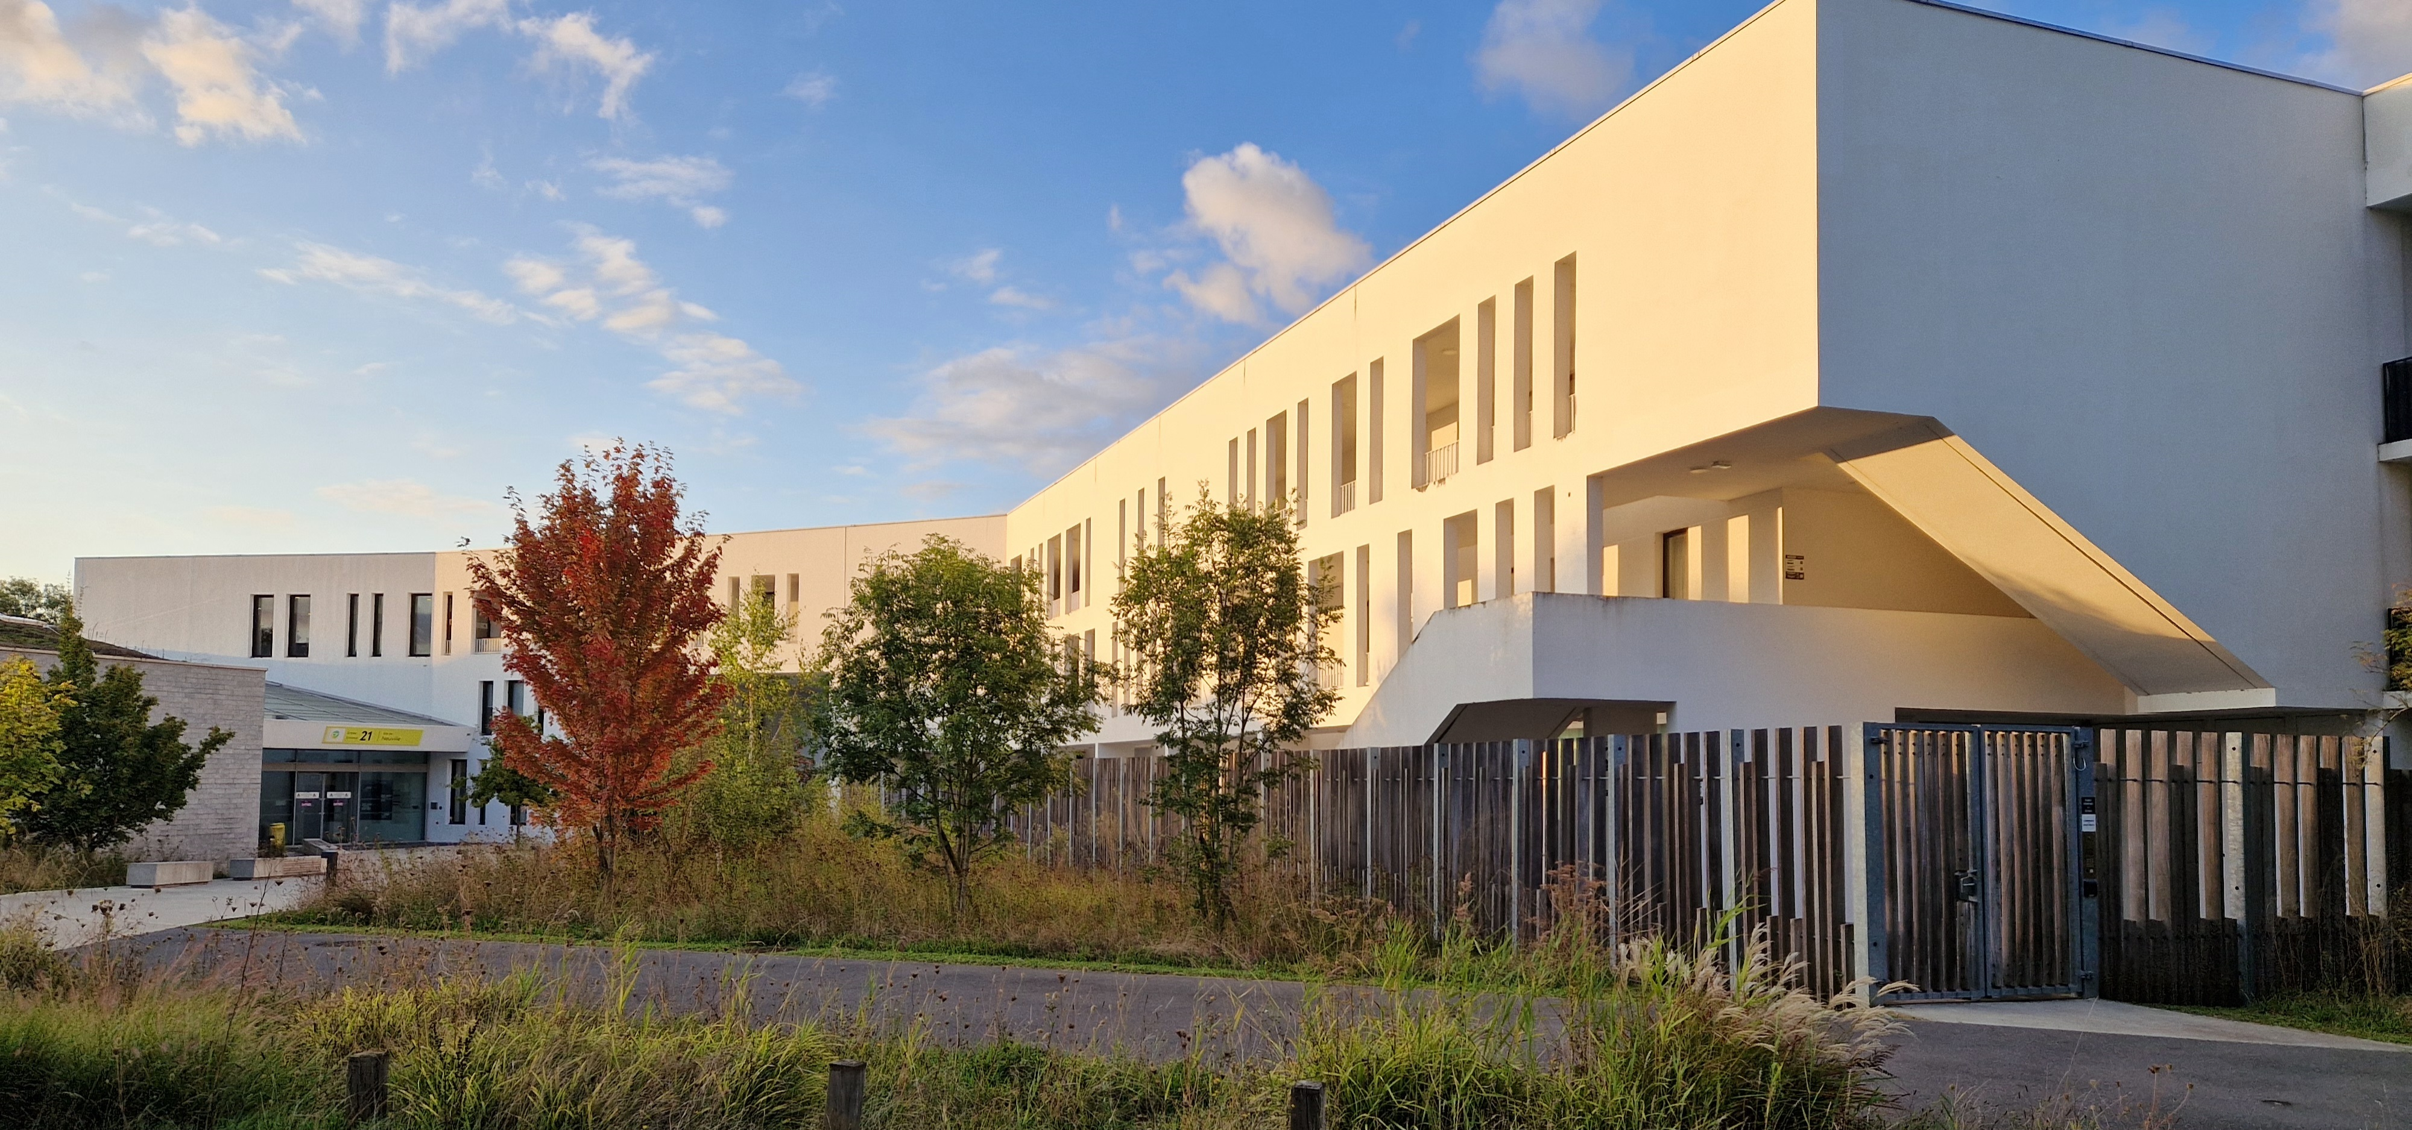

Application form and call description
Key data
Name of the coordinator | Provide the name of the person who will be the main contact with the Institute
Other participants | Provide the names of the other participants
Subject | Specify the subject of the programme (e.g. Chemistry)
Dates | Specify the preferred period of stay

Call description

General description

The purpose of the programme is to enable research to be carried out in small groups (up to three people and local collaborators) within the CY Institute for Advanced Studies. The aim is to give researchers the opportunity to advance their project or to start a new one under the best possible conditions. Visits can last up to three weeks.

Visitors will be accommodated in the residence of the Institute (a shared three-bedroom apartment) and will have a shared office during their stay. They will have access to the common and meeting rooms, as well as to the canteen of the University, which is located five minutes' walk from the Institute.

Any group of researchers from the academic community, with or without a local collaborator, can apply for the programme. Applications are accepted at any time of the year, subject to availability of funds, and decisions are taken by an ad hoc committee within three weeks of submission.

Financial arrangements

In addition to free accommodation, visitors will receive a daily allowance of €40 per person per day. Transport costs cannot be reimbursed under any circumstances, nor can accommodation not booked through the Institute.

How to apply

To apply for the programme, please fill in the application form (see the next two pages), attach three papers by members of the group published in the last five years and short CVs of the members, and send them all together as a zip file by email to cyas@cyu.fr, with all members of the group as cc. All the documents should be in pdf format. Applications can be submitted at any time during the academic year, and their receipt will be confirmed by return mail.

Application form

The application package should include the information on the four points below, as well as the following documents:

- Short CVs (2-4 pages) of all the participants
- A selection of three articles (in pdf format) published by members of the group in the last five years

The text in blue (including this line) should be removed from the application.

- Participants
Provide the list of participants (with a link to their web page), their institutions of affiliation, and the local host and their department.

Name and Surname | Affiliation | Position | Local collaborator (optional)

- Preferred period of stay
Give the period of your stay (if possible, please provide at least two options)

- Reviewers
Suggest some reviewers for your project (at least two names, together with affiliations and emails)

- Scientific project
Describe briefly your project (between 500 and 1000 characters)

