Development of graphene-based material for high-power and flexible biofuel cell

Enzymatic biofuel cells (E-BFC) offer a cheap and environmentally friendly approach for energy conversion from renewable fuels. In this device, energy from chemical oxidation of renewable fuels (i.e. sugars, ethanol, glycerol, etc.) by appropriate redox enzymes is converted to electrical energy. Comparing with conventional fuel cells or disposable batteries, biofuel cells represent more environmentally benign production of energy, because their operation does not involve toxic metals that can contaminate the surrounding environment or costly, non-renewable precious metals. E-BFC uses enzyme catalysts that can function at physiological conditions, thus E-BFC hold a great promise as a power source for implantable devices in biomedical applications.
However, the commercialization of E-BFC is still limited due to several issues. First, enzymes need to be stable and retain three dimensional structure to be catalytically active. Secondly, maintaining effective electrical communication between enzyme and electrode is also crucial because the active site of enzymes is typically buried inside the protein structure. In this collaborative proposal, we aim to develop novel electrode materials based on graphene for the anode of E-BFC to bring this device closer to practical applications (Fig. 1 and Fig. 2). The incorporation of graphene into the electrode material of E-BFC would increase the energy output as well as the lifetime of E-BFC. Flexible E-BFC for biomedical applications can also be achieved due to the unique mechanical properties of graphene.

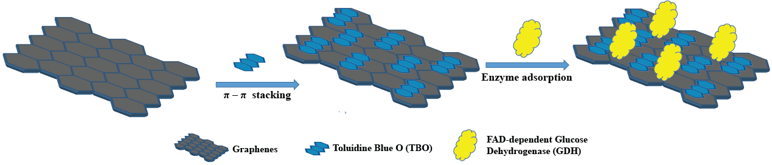
Figure 1. Schematic of immobilization of GDH enzyme and the redox mediator TBO onto graphene

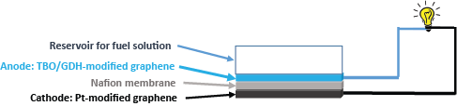

Figure 2. Schematic of a graphene-based enzymatic biofuel cell

All graphene-based materials for construcing E-BFC will be prepared at the High Tech Institute of Nguyen Tat Thanh University (Vietnam). By employing available advanced techniques for electrochemical measurements and material characterization at the LPPI – University of Cergy-Pontoise, we expect to achieve an optimized graphene-based high-power and flexible biofuel cell for electricity generation.

