**CY Advanced Studies**

**Fellows-in-Residence Programme**

|  |  |
| --- | --- |
| **Name, Surname** | Full name with a link to your website |
| **Title of the project** | Provide a title of your research project |
| **Subject** | Specify the main subject of your research (e.g. Computer science) |
| **Current affiliation and position** | Specify your home institution and your position there |
| **CY affiliation** | Indicate your host laboratory or research centre at CY Initiative |
| **Email address** |  |
| **Phone number** |  |
| **Full postal address** |  |
| **Type of fellowship** | Choose between senior, junior, and national |
| **Activities at CY AS** | Indicate what you plan to organise at the institute:  interdisciplinary conference, thematic month, doctoral course |
| **CY secondary affiliation** (optional) | For interdisciplinary research, this is mandatory |
| **Requested duration of fellowship** | This should be between 4 and 10 months for senior fellowships and up to 12 months for junior fellowships |
| **Presentation/Recommendation Letters** | Provide the names of letter writers, together with their affiliations and links to their websites |
| **Collaborators at CY Initiative** | Provide the names of your possible collaborators affiliated with laboratories and research centres of CY Initiative |

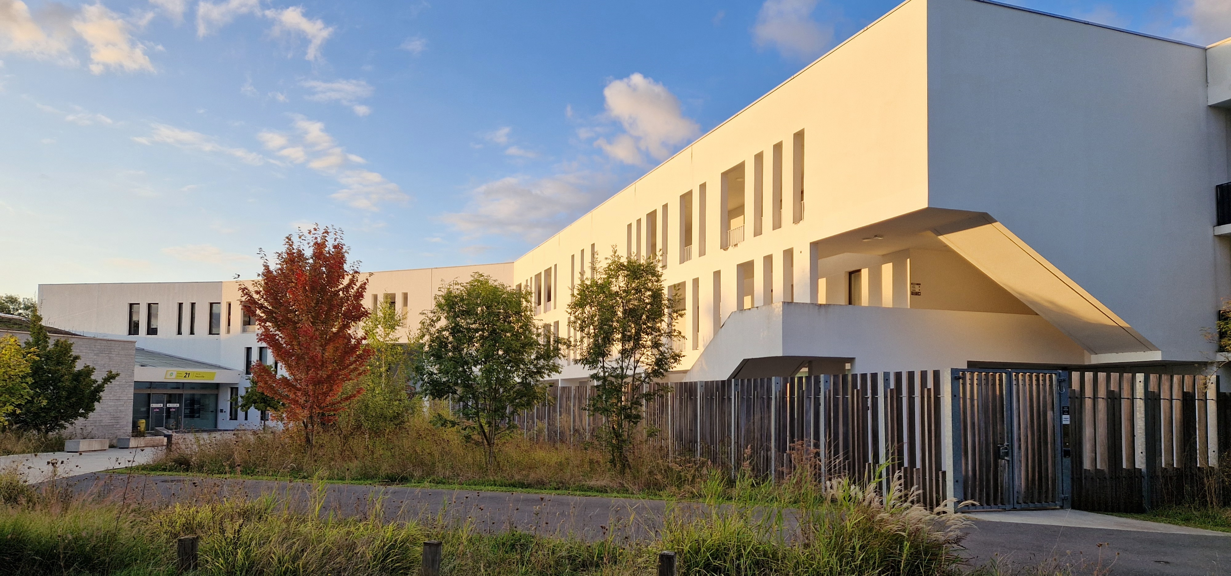

**Application form**

**Key data**

## Application package

The application package consists of the following documents:

1. Application form (this file).
2. A CV in English of no more than 10 pages highlighting publications, activities, and achievements.
3. A statement of collaboration endorsed by the director of one of the laboratories or research centres of the CY Initiative.
4. For applicants with *interdisciplinary research*: A statement of collaboration en-dorsed by the director of a second CY Initiative laboratory or research centre. Both laboratories should make a clear commitment to contribute financially to the organisation of a five-day interdisciplinary conference at CYAS.
5. For applicants who choose *Thematic Month* and/or *Doctoral course*: A completed application form of the corresponding programme.
6. For senior fellowships: A presentation letter sent to [cyas@cyu.fr](mailto:cyas@cyu.fr) by its author. The name of the letter writer should be mentioned on the title page of this form.
7. For junior fellowships: Two recommendation letters sent to [cyas@cyu.fr](mailto:cyas@cyu.fr) by their authors. Their names should be mentioned on the title page of this form.

All the documents should be in pdf format, and they should be submitted by email to [cyas@cyu.fr](mailto:cyas@cyu.fr) between 15 July and 31 October. There will be no extension of the deadline. Enquiries can be directed to the [Helpdesk](mailto:aide-aux-candidats-pour-fir-request@ml.u-cergy.fr).

The text above this line and the text in red colour should be removed from the application.

**Title of the research project**

1. **Abstract**

Describe briefly the objectives of the project and provide any relevant information on the subject.

1. **Research proposal**

Provide a detailed description of the research project, including the state of the art, specific objectives, methodology and novelty. This is a key part of the application and should be **at least three pages** (excluding the bibliography). If you prefer to do it in LaTeX, insert the outcome into this file.

1. **Interdisciplinary character of the project** (optional)

If your research has interdisciplinary character, describe the connection between the two subjects and give some details about the five-day conference you plan to organise (title, invited speakers, tentative dates, etc.) This part of the application should be **at least two pages**.

1. **Hosting of the project and planned activities**

Describe the integration of your project within the prospective host research group, including planned collaboration with researchers of CY Initiative and possible interaction with research groups in other institutions. If your research is not interdisciplinary, you need to choose at least one programme of CY AS (thematic month and/or doctoral course) and fill in the corresponding application form. The latter should be submitted as a separate pdf file.

1. **Current position and your status during the fellowship**

Describe your current position and employer. Specify your status during the fellowship (e.g., paid sabbatical, leave of absence, no position, etc.)