**CY Advanced Studies**

**Doctoral courses programme**

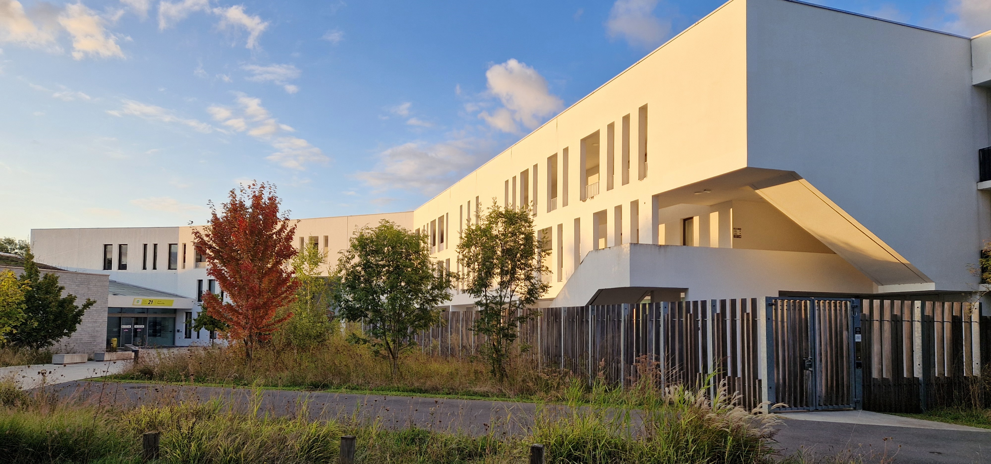

**Application form and call description**

**Key data**

|  |  |
| --- | --- |
| **Name of the lecturer** | Give your name and surname, together with a link to your web page |
| **Title of the course** | Provide a title for your course |
| **Subject** | Specify the subject of the course (e.g. Biology) |
| **Dates** | Specify the period when the course will be taught |

**Call description**

General description

The aim of the programme is to give academics the opportunity to teach an (advanced) graduate course on the subject of their research. The minimum duration of a course is 12 hours, with the possibility of extending it to a maximum of 30 hours. A lecturer will be provided with an office on the teaching days (and any other day on request) and will have access to the common room, as well as to the university canteen, which is located five minutes' walk from the Institute.

Researchers from the academic community can apply for teaching a doctoral course, and affiliation with with CY Cergy Paris University is not required. Applications are accepted at any time of the year, subject to the availability of funds, and decisions are made by an ad hoc committee within three weeks of submission.

All lectures will take place in the premises of CY Advanced Studies. They will be organised in a hybrid mode, ensuring the possibility of attending the lectures in person at CY AS and via online streaming. The lectures will be recorded and made available to the community by posting them on the Institute's YouTube page.

Financial arrangements

A lecturer affiliated to the CY Cergy Paris Université will get a financial compensation at a standard rate of overtime teaching (heure complémentaire), which is about 52€ (net) per teaching hour as of April 2025. For all other lecturers, financial compensation will be subject of negotiations.

How to apply

To apply for the programme, please fill in the application form (see the next page), attach three papers published in the last five years and a short CV, and send them all together as a zip file by email to [cyas@cyu.fr](mailto:cyas@cyu.fr?subject=Application%20for%20research%20in%20group). All the documents should be in pdf format. Applications can be submitted at any time during the academic year, and their receipt will be confirmed by return mail.

**Application form**

The application package should include the information on the three or four points below, as well as the following documents:

1. Short CV (2-4 pages) of the lecturer
2. A selection of three articles (in pdf format) published by the lecturer in the last five years

The text in blue (including this line) should be removed from the application.

1. **Title and plan of the course**
2. **Dates**

Specify the period during which the course will be taught and the preferred time slots.

1. **Audience**

Describe the target audience and indicate any links with master’s programmes at CY Cergy Paris University. If there are students who are certain to attend the course, please provide a list.

1. **Additional information** (optional)

Provide any other information you find useful.