**CY Advanced Studies**

**Thematic Months Programme**

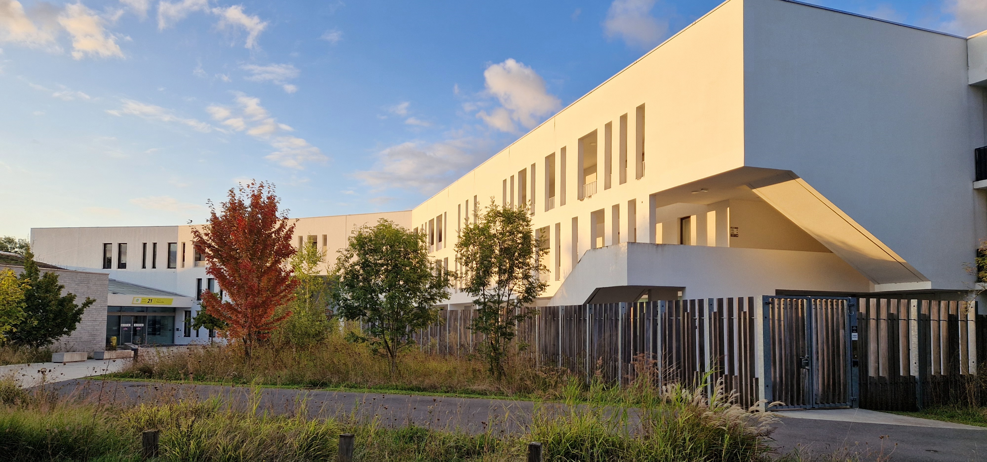

**Application form**

**Key data**

|  |  |
| --- | --- |
| **Name of the coordinator** | Provide the name of the person (along with a link to their website) who will be the main contact with the Institute |
| **Other organisers of the programme** | Provide the names and the websites of the other organisers |
| **Subject** | Specify the subject of the programme (e.g. Physics) |
| **Dates** | Specify the exact dates of the programme (no earlier than 6 months from the date of submission) |
| **Budget** | Indicate the total budget to be invested by the organisers; do not include funds raised by participants from other sources |
| **Planned number of courses** | Provide the total number of different courses |
| **Total number of teaching hours** | Indicate the total duration of the courses |
| **CY laboratory concerned** | Specify a CY laboratory involved in the programme (if any) |

The application package should include the information on the four or five points below, as well as the following documents:

1. Short CVs (2-4 pages) of all the organisers
2. A selection of five articles (in pdf format) by the programme coordinator

The text above this line should be removed from the application. The length of this document should be 3-6 pages.

**Title of the programme**

1. **Objectives**

Describe the objectives of the thematic programme and provide any relevant information about the subject.

1. **Tentative programme**

Describe the general structure of the programme, mentioning in particular the courses to be taught and the names of the lecturers. If the programme includes a workshop or a conference, provide a provisional list of speakers.

1. **Participants**

Describe the scientific background of potential participants and the strategy for attracting them.

1. **Budget**

Provide a reasonably detailed description of the budget (including the support for young parti-cipants). Indicate the total duration of the invited professorships you are requesting.

Please note that the Institute will invest a maximum of €25,000 in a three-week programme. This should be no more than 70% of the total budget managed by the organisers.

1. **Miscellanea (optional)**

Provide any other information you find relevant.